Aluminum High Performance Door Rapid Roll® 3000  (High Speed Door) |  | 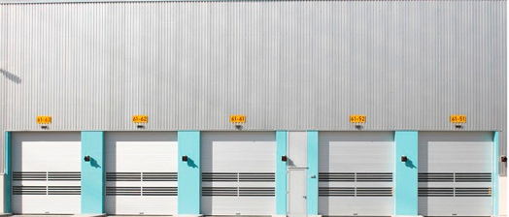
Door type | RR3000 | PL. indicate your requirement
Description | Aluminum High Performance Door, opening in vertical direction, for interior and exterior use
Side frames | Edged galvanized steel profiles. Springs for curtain tension and counterbalance in the side frame.
Door curtain | Ecru anodized double walled aluminum lamellas, hinge less connected by means of flexible heavy belts, wear-less to wind up without to contact each other, each single lamella can be replaced easily, pre-fitted on the top roll.
Wind protection | Class 3-4 (EN 12424)
Drive unit | Gear motor, pluggable electrical connections
Protection | IP 55
Control system | MCCVector Control, with vector control technology and boost function at start-up. Graphic display and foil keypad for easy guided operation. Easy access to all important information for operation and service
Control voltage | 24 V DC
Supply voltage | 3L/(N)PE 380/400/415/440V; 50/60 Hz  Transformer necessary for 230/480/500V; 50/60 Hz
Safety devices | - Patented, contact-free pre-running safety photocell (transmitter/receiver)  - Stationary safety photocell (transmitter/receiver)  - Drop down protection by integrated balancing system
Manual activation | By releasing the brake at ground level. Partly opening by means of the pre-stressed tension springs
Opening / closing speed | Up to max. 2,2/0,7 m/s
Size max | (DW x DH): 5000 x 5000 mm
Make | ALBANY Rapid Roll® 3000
Options:
Covers | - Top roll cover made of anodized aluminum  - Motor cover made of anodized aluminum
Surface/material | - Side frames with covers made of anodized aluminum  - Side frames colored  - Aluminum lamellas colored
Miscellaneous | - Lamellas with windows  - insulation  - extended flexible seal
Actuators | Additional safety devices
Delivery | Installation incl. wiring

